

**课程设计报告**

**课 程 名 称：Fundamentals of Multimedia**

**课程设计名称：Multimedia**

**系部名称：International Education Center**

**学生姓名：Arafat Hoshen**

**班 级：class 3**

**学 号： 2……..**

**成 绩：**

**指导教师：潍坊刘**

**开课时间：2019-2020学年第2学期**

### 

### **Index**

Contents

Index 1

Introduction of Multimedia 2

Multimedia Software Tools 3

Graphics and Image Data Representations 4

1-Bit Images 5

Color in Image and Video. 6

Color Models in Images . 7

RGB Color Model for Displays . 8

Multisensor Cameras . 9

Color Models in Video 10

Video Color Transforms 11

YUV Color Model 12

Basics of Digital Audio 13

What is Sound? 14

References 15

# **Introduction of Multimedia**

**Multimedia is a representation of information in an attractive and interactive manner with the use of a combination of text, audio, video, graphics and animation. In other words we can say that Multimedia is a computerized method of presenting information combining textual data, audio, visuals (video), graphics and animations. For examples: E-Mail, Yahoo Messenger, Video Conferencing, and Multimedia Message Service (MMS).**

**Multimedia as name suggests is the combination of Multi and Media that is many types of media (hardware/software) used for communication of information.**

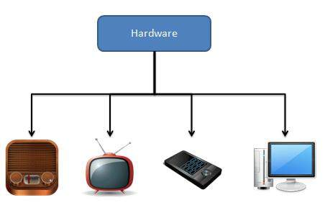

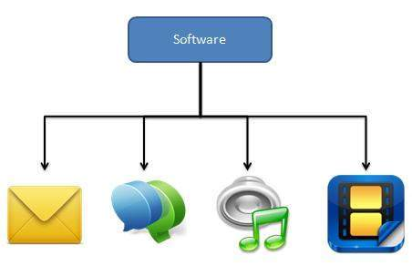

# 

# **Multimedia Software Tools**

1. **1. Multimedia Software Tools**
2. [**2.**](https://image.slidesharecdn.com/multimediasoftwaretools-120320065118-phpapp01/95/multimedia-software-tools-2-728.jpg?cb=1332226816)**• The basic tool set for building a multimedia project can be divided into five categories: – Painting and Drawing Tools – 3-D Modeling and animation tools – Image editing tools – Sound editing tools – Animation Video – Digital Movie tools**
3. [**3.**](https://image.slidesharecdn.com/multimediasoftwaretools-120320065118-phpapp01/95/multimedia-software-tools-3-728.jpg?cb=1332226816)**Painting and Drawing Tools• Painting and drawing tools generally come with a graphical user interface with pull down menus for quick selection.• You can create almost all kinds of possible shapes and resize them.• Drawing file can be imported or exported in many image formats like .gif, .tif, .jpg, .bmp, tec.• A good drawing software – “Corel Draw”**
4. [**4.**](https://image.slidesharecdn.com/multimediasoftwaretools-120320065118-phpapp01/95/multimedia-software-tools-4-728.jpg?cb=1332226816)**3D Modeling tools• Realism means that you depict things in the way they actually are.• It tools the objects that appear in perception in your project can look realistic.• These tools offer features like multiple windows to view your design in each dimension.• Tools provide drag and drop menu.• A good 3D modeling tool is “3D Studio Max”.**
5. [**5.**](https://image.slidesharecdn.com/multimediasoftwaretools-120320065118-phpapp01/95/multimedia-software-tools-5-728.jpg?cb=1332226816)**Image editing tools• These tools are used to edit existing bitmap images and pictures.• They are similar to painting and drawing tools as they can also create images from scratch.• It is also capable of converting the image data type file format.• It is used usually for reinventing and recreating the image.• Image process software – Adobe Photoshop & Paint Shop pro.**
6. [**6.**](https://image.slidesharecdn.com/multimediasoftwaretools-120320065118-phpapp01/95/multimedia-software-tools-6-728.jpg?cb=1332226816)**Sound editing tools• Sound editing tools let you hear sound as well as visualize it.• You can cut/copy and paste sound edit it with great accuracy.• You can integrate sound into your multimedia project very easily by using sound editing tools.• A good sound editing software is “Cool Edit” and “Sound Forge”.**
7. [**7.**](https://image.slidesharecdn.com/multimediasoftwaretools-120320065118-phpapp01/95/multimedia-software-tools-7-728.jpg?cb=1332226816)**Animation, Video and digital movies editing tools • Animations are graphic scenes played back sequentially and rapidly. • These tools enable you to edit and assemble video clips captured from camera, animations and other sources. • The completed clip with added transition and visual effects could be played back. • Adobe Premiere and Media Shop Pro are two good example of these tools.**

**For a concrete appreciation of the current state of multimedia software tools available for carrying out tasks in multimedia, we now include a quick overview of software categories and products. These tools are really only the beginning—a fully functional multimedia project can also call for stand-alone programming as well as just the use of predefined tools to fully exercise the capabilities of machines and the Internet.2 In courses we teach using this text, students are encouraged to try these tools, producing full-blown and creative multimedia productions. Yet this textbook is not a “how-to” book about using these tools—it is about understanding the fundamental design principles behind these tools! With a clear understanding of the key multimedia data structures, algorithms, and protocols, a student can make smarter and 2 See the accompanying website for several interesting uses of software tools. In a typical computer science course in multimedia, the tools described here might be used to create a small multimedia production as a first assignment. Some of the tools are powerful enough that they might also form part of a course project. 16 1 Introduction to Multimedia advanced use of such tools, so as to fully unleash their potentials, and even improve the tools themselves or develop new tools. The categories of software tools we examine here are • Music sequencing and notation • Digital audio • Graphics and image editing • Video editing •** **Animation • Multimedia authoring.**

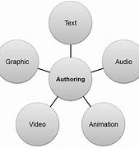

# **Graphics and Image Data Representations**

**The number of file formats used in multimedia continues to proliferate [1]. For example, Table 3.1 shows a list of file formats used in the popular product Adobe Premiere. In this chapter, we shall study just a few popular file formats, to develop a sense of how they operate. We concentrate on GIF and JPG image file formats, since the GIF file format is one of the simplest and contains several fundamental features, and the JPG file format is arguably the most important overall. To begin with, we discuss the features of file formats in general.**

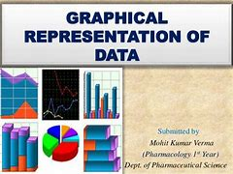

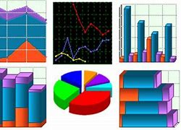

## **1-Bit Images**

**Images consist of pixels—picture elements in digital images. A 1-bit image consists of on and off bits only and thus is the simplest type of image. Each pixel is stored as a single bit (0 or 1). Hence, such an image is also referred to as a binary image. It is also sometimes called a 1-bit monochrome image since it contains no color. Figure 3.1 shows a 1-bit monochrome image (called “Lena” by multimedia scientists—this is a standard image used to illustrate many algorithms). A 640×480 monochrome image requires 38.4 kilobytes (kB) of storage (= 640×480/8). Monochrome 1-bit images can be satisfactory for pictures containing only simple graphics and text. Moreover, fax machines use 1-bit data, so in fact 1-bit images are still**

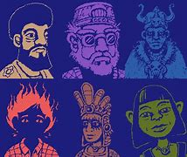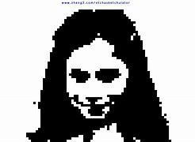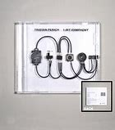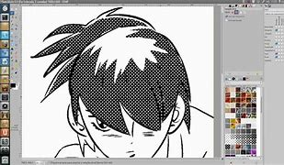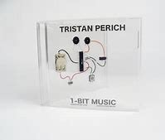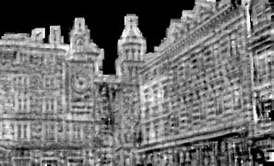

# **Color in Image and Video.**

**Recall from high school that light is an electromagnetic wave, and that its color is characterized by the wavelength of the wave. Laser light consists of a single wavelength: e.g., a ruby laser produces a bright, scarlet red beam. So if we were to make a plot of the light intensity versus wavelength, we would see a spike at the appropriate red wavelength, and no other contribution to the light. In contrast, most light sources produce contributions over many wavelengths. However, humans cannot detect all light, but just contributions that fall in the “visible wavelengths.” Short wavelengths produce a blue sensation, and long wavelengths produce a red one. We measure visible light using a device called a spectrophotometer, by reflecting light from a diffraction grating (a ruled surface) that spreads out the different wavelengths much as a prism does. Figure 4.1 shows the phenomenon that white light contains all the colors of a rainbow. If you have ever looked through a toy prism, you will have noticed that a rainbow effect is generated—the effect due to a natural**

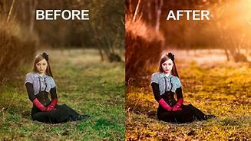

**This text covers state-of-the-art color image and video enhancement techniques. The book examines the multivariate nature of color image/video data as it pertains to contrast enhancement, color correction (equalization, harmonization, normalization, balancing, constancy, etc.)**

## **Color Models in Images .**

**A color model is an abstract mathematical model describing the way colors can be represented as tuples of numbers, typically as three or four values or color components. When this model is associated with a precise description of how the components are to be interpreted (viewing conditions, etc.), the resulting set of colors is called "color space." This section describes ways in which human color vision can be modeled**

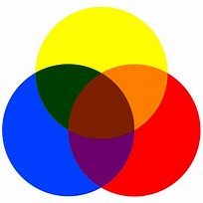

## **RGB Color Model for Displays .**

**The RGB color model is an additive color model in which red, green, and blue light are added together in various ways to reproduce a broad array of colors. The name of the model comes from the initials of the three additive primary colors, red, green, and blue.  
The main purpose of the RGB color model is for the sensing, representation, and display of images in electronic systems, such as televisions and computers**

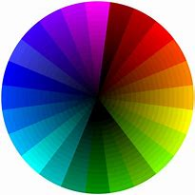

## **Multisensor Cameras .**

**Multisensor cameras are well suited for railway stations, metro stations and airports and for squares, stadiums, campuses and parking lots. They’re also ideal for perimeter surveillance around critical infrastructure, public or government buildings, banks and healthcare centers.** More accurate color can be **achieved by using cameras with more than three sensors, i.e., more than three color filters. One way of doing this is by using a rotating filter, which places a different color filter in the light path over a quick series of shots. In work on capture of artwork at the Museum of Modern Art in New York City, a six-channel camera [10] has been used to accurately capture images of important artworks, such that images are closer to full-spectrum; this work uses an altered color filter checkerboard array, or set of these, built into the camera (“Art Spectral Imaging”). Part of work in this direction also has included removing the near-infrared filter typically placed in a camera, so as to extend the camera’s sensitivity into the infrared [11].**

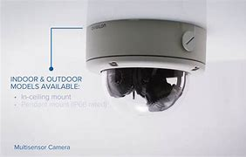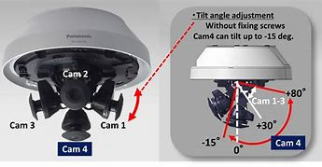

# **Color Models in Video**

## **Video Color Transforms**

**Methods of dealing with color in digital video largely derive from older analog methods of coding color for TV. Typically, some version of the luminance is combined with color information in a single signal. For example, a matrix transform method similar to Eq. (4.19) called YIQ is used to transmit TV signals in North America and Japan. In Europe, video tape uses the PAL or SECAM codings, which are based on TV that uses a matrix transform called YUV.**

## **YUV Color Model**

**Initially, YUV coding was used for PAL analog video. A version of YUV is now also used in the CCIR 601 standard for digital video. First, it codes a luminance signal (for gamma-corrected signals) equal to Y ≡ in Eq. (4.20). (Recall that Y ≡ is often called the “luma”). The luma Y ≡ is similar, but not exactly the same as, the CIE luminance value Y, gamma-corrected. In multimedia, practitioners often blur the difference and simply refer to both as the luminance. As well as magnitude or brightness we need a colorfulness scale, and to this end chrominance refers to the difference between a color and a reference white at the same luminance. It can be represented by the color differences U, V: U = B≡ − Y ≡ V = R≡ − Y ≡ (4.30) From Eqs. (4.20), (4.30) reads ⎝ ⎞ Y ≡ U V ⎟ ⎠ = ⎝ ⎞ 0.299 0.587 0.114 −0.299 −0.587 0.886 0.701 −0.587 −0.114 ⎟ ⎠ ⎝ ⎞ R≡ G≡ B≡ ⎟ ⎠ (4.31) One goes backwards, from (Y ≡ , U, V) to (R≡ , G≡ , B≡ ), by inverting the matrix in Eq. (4.31). Note that for a gray pixel, with R≡ = G≡ = B≡ , the luminance Y ≡ is equal to that same gray value, R≡ , say, since the sum of the coefficients in Eq. (4.20) is 0.299 + 0.587 + 0.114 = 1.0. Also, for such a gray (“black and white”) image, the chrominance (U, V) is zero since the sum of coefficients in each of the lower two equations in (4.31) is zero. Hence color TV could be displayed on a precursor black and white television by just using the Y ≡ signal.3 And for backwards compatibility color TV uses old black and white signals with no color information by identifying the signal with Y ≡ . Finally, in the actual implementation U and V are rescaled for purposes of having a more convenient maximum and minimum. For analog video, the scales were chosen such that each of U or V is limited to the range between ±0.5 times the maximum of Y ≡ [16]. (Note that actual voltages are in another, non-**

# **Basics of Digital Audio**

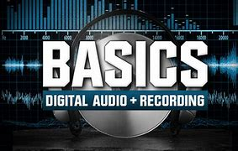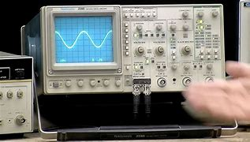

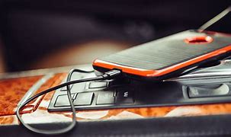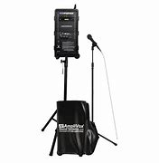

* **Digital Audio Technology and Binary Numbers. In very basic terms, a digital audio system is able to take a continuous...**
* **Sample Rate. The sample rateof a digital audio technology system relates to how often the analog signal is sampled each...**
* **Bit Depth. The second major area of digital audio technology is the bit depth. When a sample...**

## **What is Sound?**



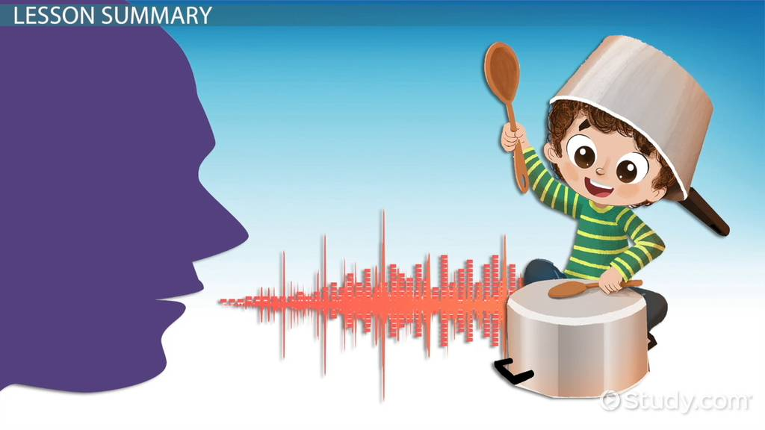

* **vibrations that travel through the air or another medium and can be heard when they reach a person's or animal's ear.**
* **"light travels faster than sound"**
* **sound produced by continuous and regular vibrations, as opposed to noise.**
* **music, speech, and sound effects when recorded and used to accompany a film, video, or broadcast.**
* **"a sound studio"**
* **an idea or impression conveyed by words.**
* **"you've had a hard day, by the sound of it"**

# **References**

1. **Fundamentals of Multimedia. Second Edition**

**Ze-Nian Li Mark S. Drew Jiangchuan Liu**

1. **From Google**

# Acknowledge

I would like to express my special thanks of gratitude to my teacher潍坊刘 laoshi as well as our principal 潍坊刘 who gave me the golden opportunity to do this wonderful project on the topic making multimedia priject.which also helped me in doing a lot of Research and i came to know about so many new things I am really thankful to them.